Clean Sky awards the 11th ‘Clean Sky Synergy Label’

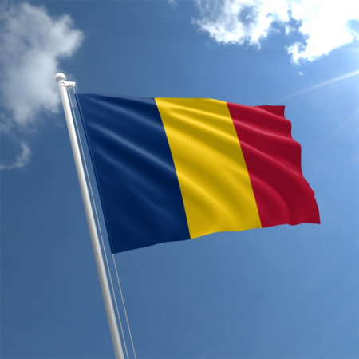

03 October 2019

Clean Sky has awarded the 11th ‘Clean Sky Synergy Label’ to the Romanian proposal ‘INFRASEAL’, which is complementary to Clean Sky scope and objectives. ‘Clean Sky Synergy Label’ is a quality label that can be awarded to complementary activities proposed by either a successful applicant in a Clean Sky 2 call or by a Clean Sky 2 beneficiary during the implementation of a CS project.   
    
The INFRASEAL (Development of research Infrastructure for rotating labyrinth Seals characterization) is a complementary activity to the Clean Sky topic ‘Airflow characterization through rotating labyrinth seal’ under the Engine research platform. This project aims to expand the capabilities for advanced experimental and numerical investigations in order to characterise the airflow through rotating labyrinth seals for higher parameters engines. These extended capabilities are meant to provide the foundation for extending the usability of the Ultra-High Propulsive Efficiency (UHPE) demonstrator validated for Short/Medium Range aircraft market.   
    
After the awarding of the ‘Clean Sky Synergy Label’, INFRASEAL is entitled to be submitted for funding in the national COMPLEMENT Call that support synergies between Clean JU and ESIF. The maximum ESIF contribution for a COMPLEMENT project is about €2 million. COMPLEMENT is a dedicated action (through [call for proposals](http://www.poc.research.gov.ro/)) launched by the Romanian Ministry for Research and Innovation, for supporting synergies between ESIF and Horizon 2020 and other international R&D programmes, including CSJU.   
    
Learn more about the ‘Clean Sky Synergy Label’ and how to propose a complementary activity in the link [here](https://www.cleansky.eu/structural-funds-and-regions).